**27-Aug-2024**

**Internship Day - 28 Report:**

**Using AWS Simple Email Service (SES) to Send Emails**

**Overview**

AWS Simple Email Service (SES) allows users to send and receive emails securely and reliably. Below are the steps to set up and send emails using AWS SES.

**Steps to Use AWS SES**

1. **Access AWS SES:**Log in to the AWS Management Console and search for "SES."  
   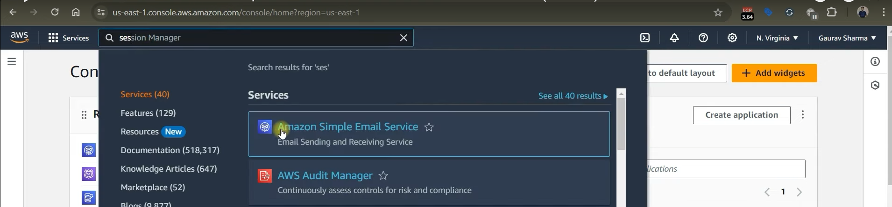
2. **Create Email Identity:**

* Click on "Identities" and then select "Create Identity."  
    
  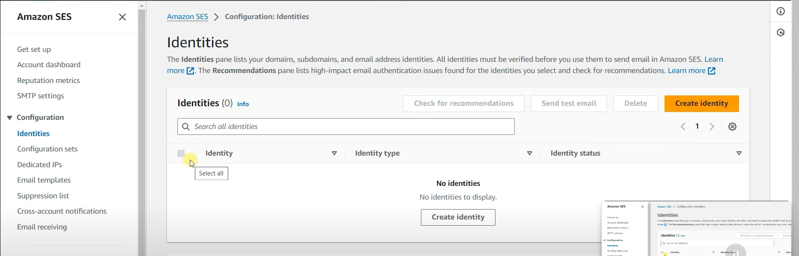
* Choose "Email Address" and enter the email address you want to verify.

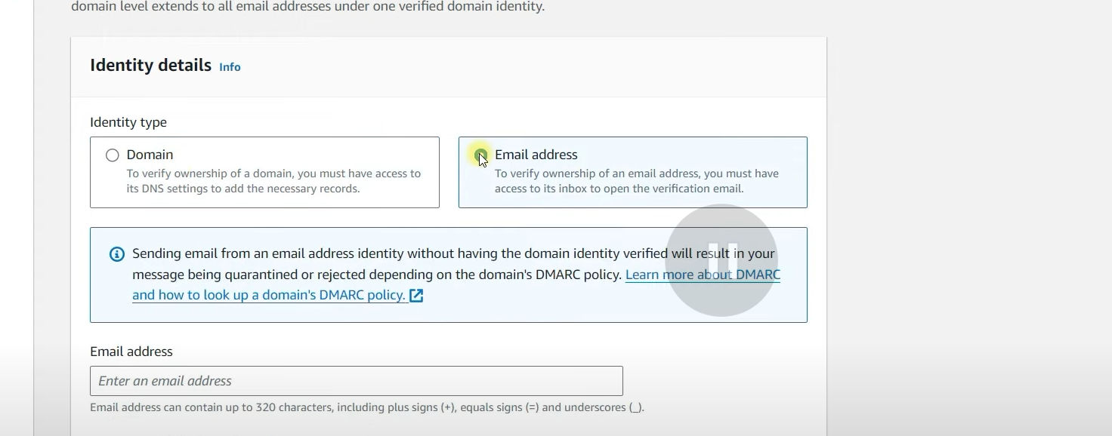

* Click "Create Identity."  
    
  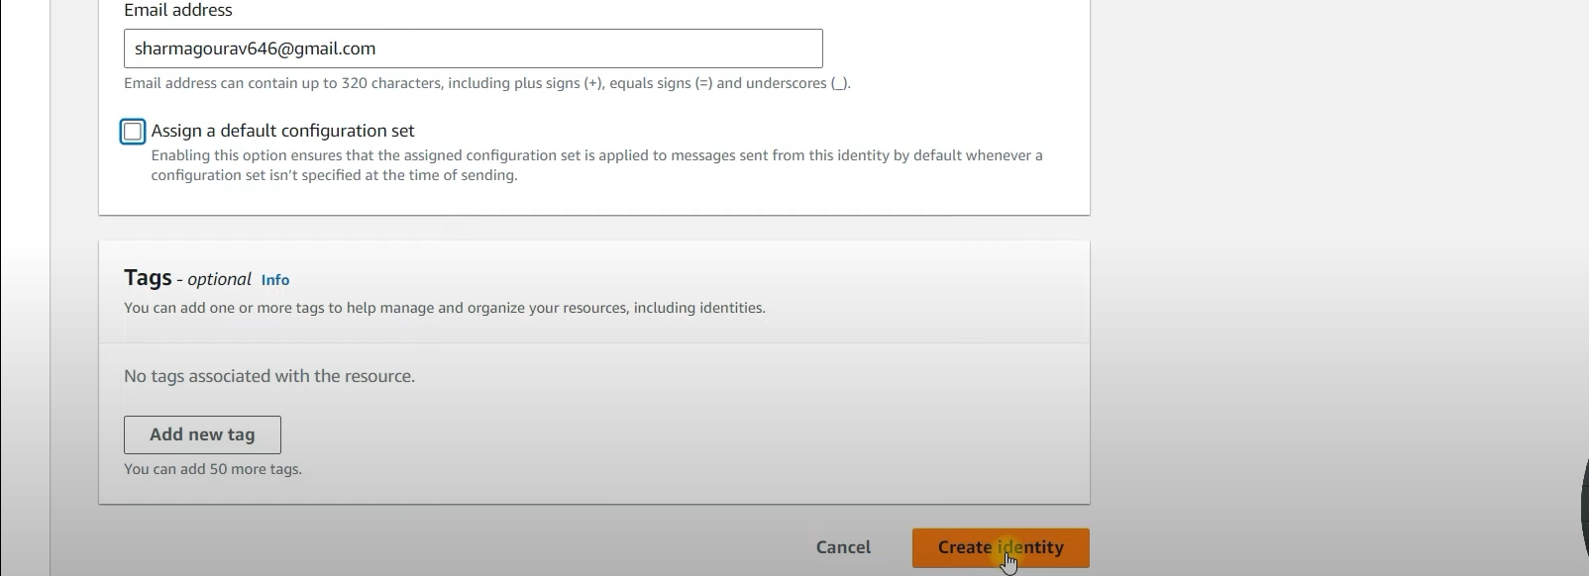

1. **Verify Email Address:**

* Check your inbox for a verification email from AWS SES.  
    
  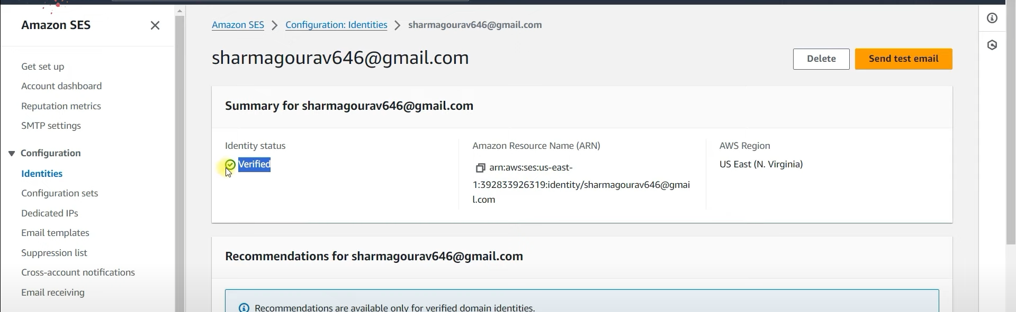
* Click the verification link in the email to confirm your address.
* Refresh the SES console to see the verified status.

1. **Send a Test Email:** a. Click on "Send Test Email" in the SES console.  
    b. Fill in the required information (recipient, subject, and body).

c. Click "Send."



1. **Check Spam Folder:**  
   If the email ends up in the spam folder, note that this can happen with unverified senders.
2. **Request Production Access:**

* Go to the Account Dashboard and click on "View the Getting Started Page."
* Request production access by selecting the mail type, entering your website URL, and providing a description of your email use case.
* Specify the email addresses that will receive emails and submit the request.

1. **Final Notes:**

* Ensure that you have created and verified an email identity.
* Understand that initially, you can only send emails to verified addresses until you receive production access.

By following these steps, you can effectively set up and use AWS SES to send emails from your applications.

**28-Aug-2024**

**Internship Day - 29 Report:**

**Using AWS CLI: Configuration and Instance Creation Guide**

This document outlines the steps to install and configure the AWS Command Line Interface (CLI), create a new user, and launch an AWS EC2 instance using the CLI.

**1. Installing the AWS CLI**

**For Windows:**

1. Download the AWS CLI MSI installer from here.
2. Run the installer and follow the on-screen instructions.
3. Verify the installation by opening Command Prompt and running:  
     
   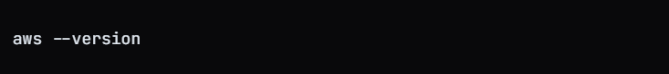

**For Linux:**

1. Download the AWS CLI installation package:

curl "https://awscli.amazonaws.com/awscli-exe-linux-x86_64.zip" -o "awscliv2.zip"

1. **Unzip the downloaded file:**  
     
   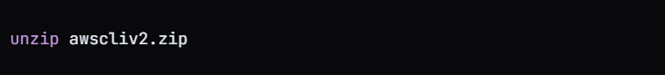
2. **Install the AWS CLI:**  
     
   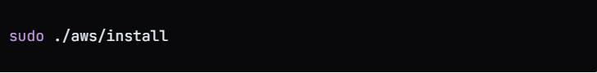
3. **Verify the installation:**  
     
   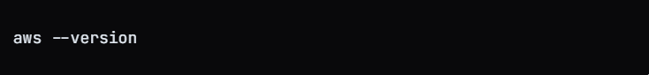

**2. Configuring AWS CLI**

To configure the AWS CLI, you need to set up your access keys and default region.

1. **Create a new IAM user:**

* Go to the AWS Management Console.
* Navigate to IAM (Identity and Access Management).
* Click on Users and then Add user.
* Provide a username and select Programmatic access.
* Set permissions by adding the user to a group or attaching policies directly.

1. **Create access keys:**

* After creating the user, go to the User Security Credentials tab.
* Scroll down to Access keys and click on Create access key.
* Select CLI, check the acknowledgment box, and proceed.
* Download the CSV file containing your access key and secret key.

1. **Configure the AWS CLI: Open your terminal and run: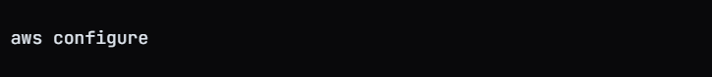 Enter the following information when prompted:**i. AWS Access Key ID

ii. AWS Secret Access Key

iii. Default region name (e.g., ap-south-1)

iv. Default output format (e.g., json)

**3. Creating an EC2 Instance Using AWS CLI**

**1. Describe available instances: To view existing instances, use:**

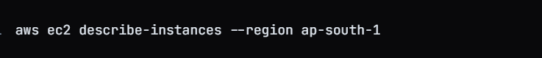 **2. Run a new EC2 instance: Use the following command to launch an EC2 instance. Replace <ami-id> with the actual AMI ID you wish to use:**aws ec2 run-instances --image-id <ami-id> --instance-type t2.micro --region ap-south-1

**29-Aug-2024**

**Internship Day - 30 Report:**

**Test**

**30-Aug-2024**

**Internship Day - 31 Report:**

**Test**